**Lesson 05 Demo 01**

**Building a To-Do List Application Using GitHub Copilot**

**Objective:** To demonstrate the code generation and enhancement of a To-Do List application using GitHub Copilot

**Tools required:** Visual Studio Code, node js, Chat GPT and GitHub Copilot

**Prerequisites:** NA

Steps to be followed:

1. Integrate GitHub Copilot with Visual Studio
2. Create React JS Project with help of Chat GPT
3. Create User Defined component with help of GitHub Copilot which help To-Do List application.

**Note:** Create an account on <https://github.com/features/copilot> to access it in Visual Studio. Generative AI tool used in this exercise can produce varied outputs even when presented with similar prompts. Thus, you may get different outputs for the same prompt.

**Step 1: Integrate GitHub Copilot with Visual Studio**

* 1. Install the **GitHub Copilot** extension in Visual Studio to use generative AI for   
     code generation

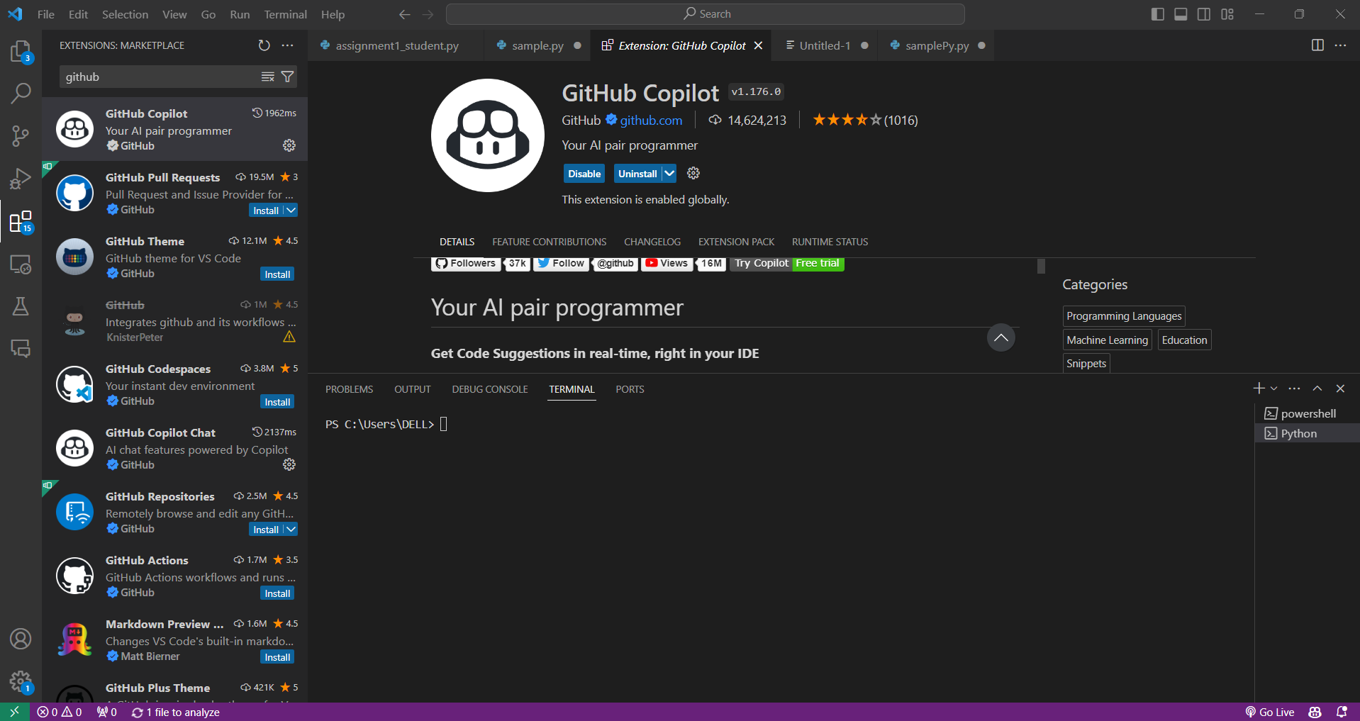

Once the installation and sign-in are completed, a message will appear as   
shown below:

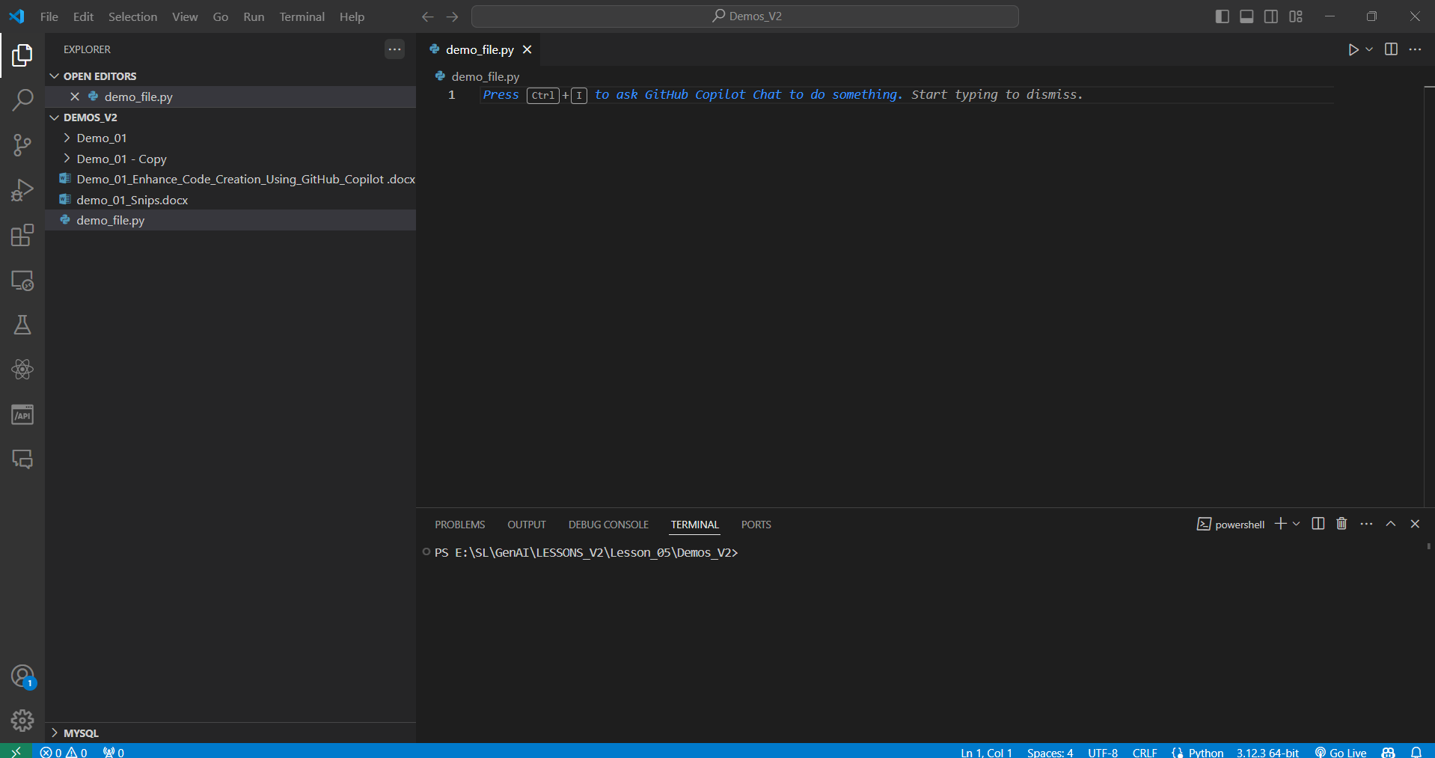

Step 2: Create React JS Project with help of Chat GPT

2.1 Open the Chat GPT and write the prompt message as

“Step to create the React JS Project with help of new version”

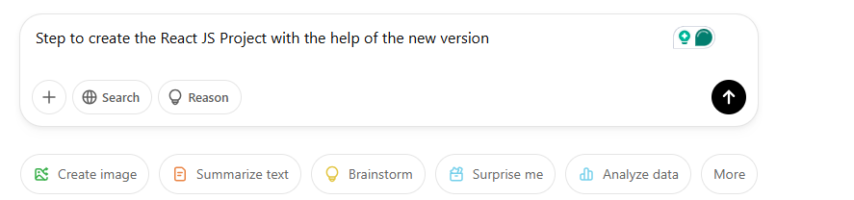

The prompt message generated as

**Prerequisites**

Ensure the following is installed on your system:

1. **Node.js** (Latest LTS version recommended) – [Download Node.js](https://nodejs.org/)

If node JS is not installed please installed with below URL as

https://nodejs.org/en

1. **npm** (Comes with Node.js) or **pnpm/yarn** (optional package managers)

Check your Node.js and npm versions:

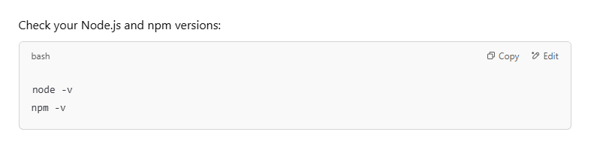

**🚀 Step 1: Set Up a New React Project**

Use the latest **create-react-app alternative**: **Vite** or **Create React with Next.js**.

**✅ Option 1: Using create-react-app (Still Supported)**

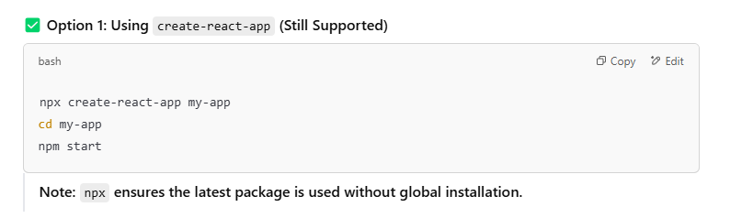

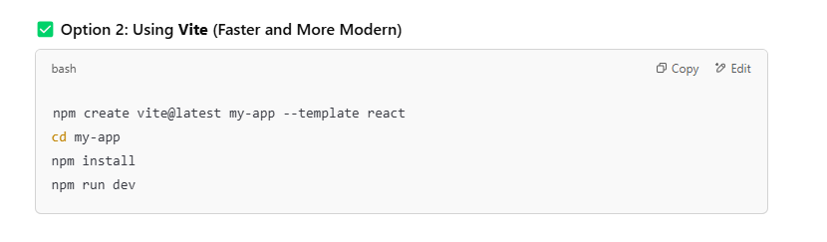

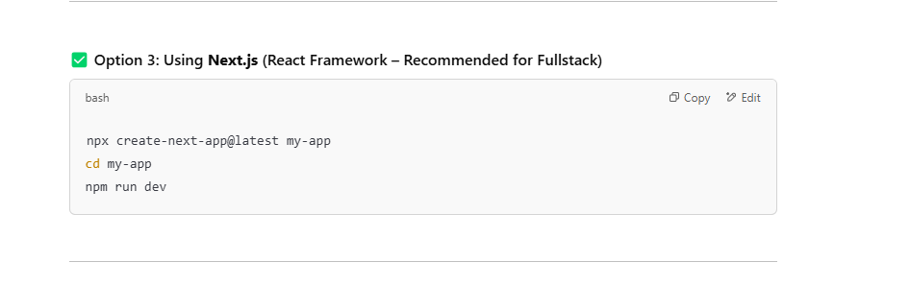

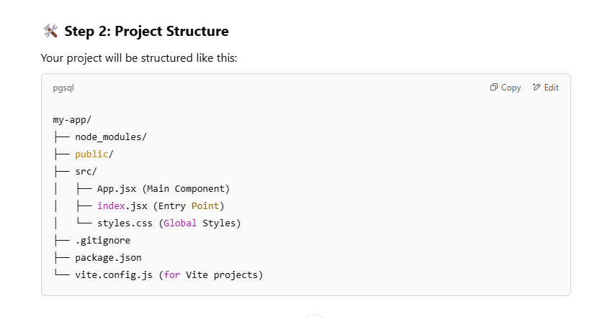

Here in this demo, we use 2nd option.

**npm create vite@latest my-to-do-app --template react**

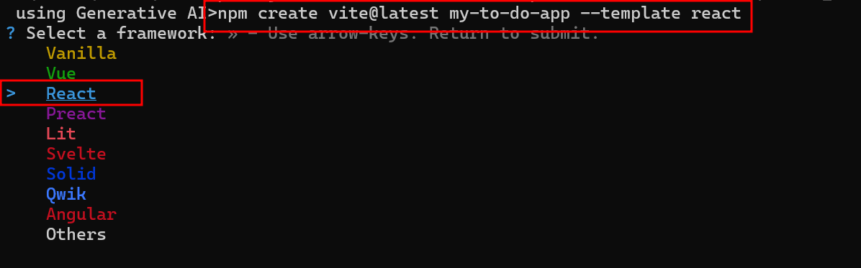

Here select, the option as React

Here select as JavaScript

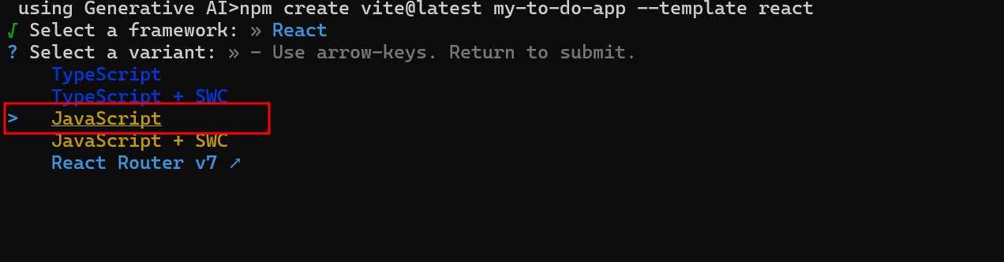

Now move inside a project folder using cd project-name

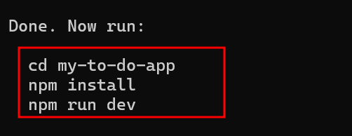

Then installed required dependencies. Run the command as **npm install**

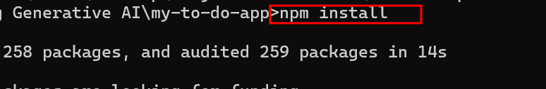

To run the project we need to use the below command as **npm run dev**

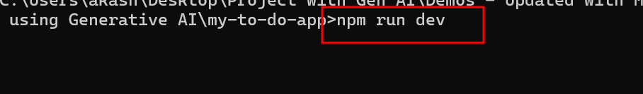

2.3 Now open this project in VS code.

The project structure is

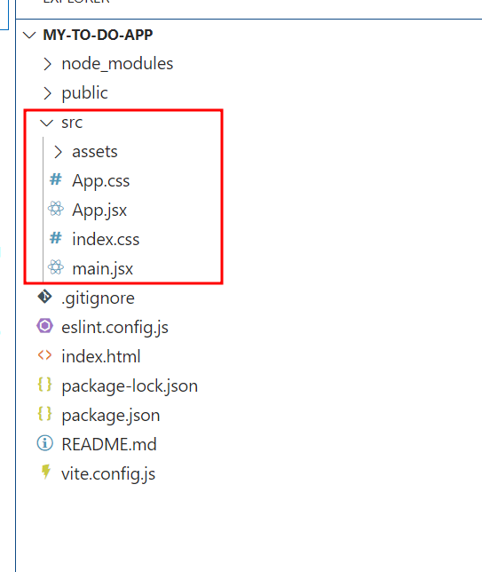

Here we create the project with configuration as vite. **Vite** (pronounced "veet", meaning "fast" in French) is a **next-generation frontend build tool** that provides an extremely fast development experience for **React, Vue, Svelte, and other modern frameworks**. It was created by **Evan You** (the creator of Vue.js).

So in Reat with vite configuration extension of file is .jsx. But if you need to .js also not problem. So file can be .jsx or .js both are same.

2.4 Now run the project using the **npm run dev** command.

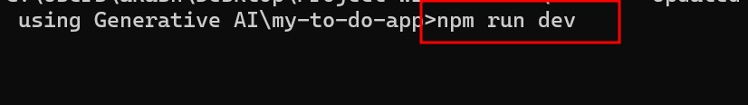

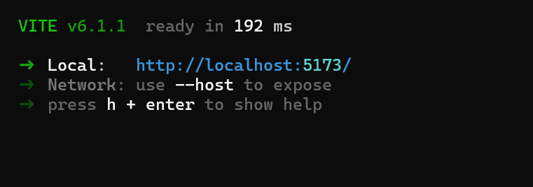

Open the project in below URL.

<http://localhost:5173/>

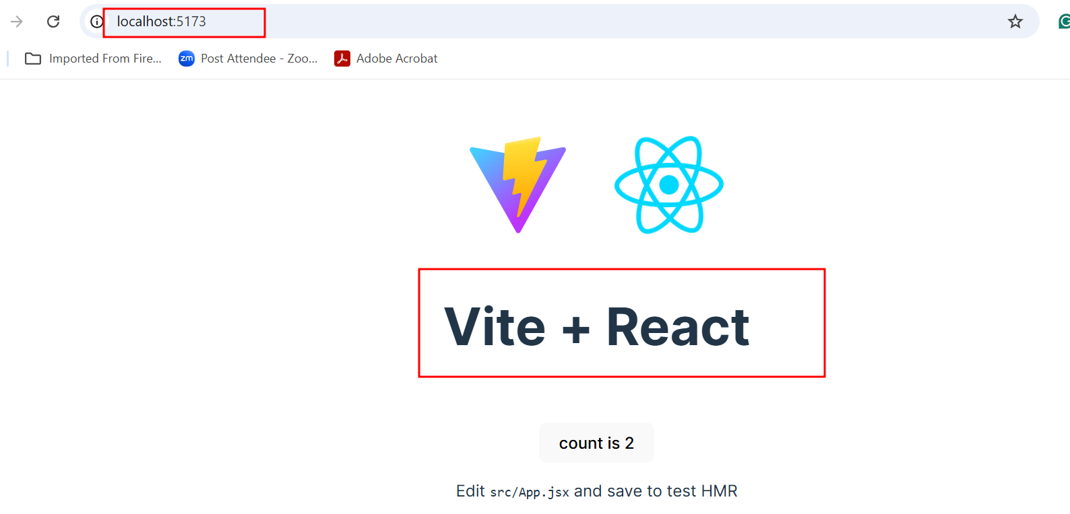

Step 3 : Create User Defined component with help of GitHub Copilot

3.1 Now we will create the new component with help of GitHub Copilot

Create a **ToDoComponent.jsx** file inside a src folder.

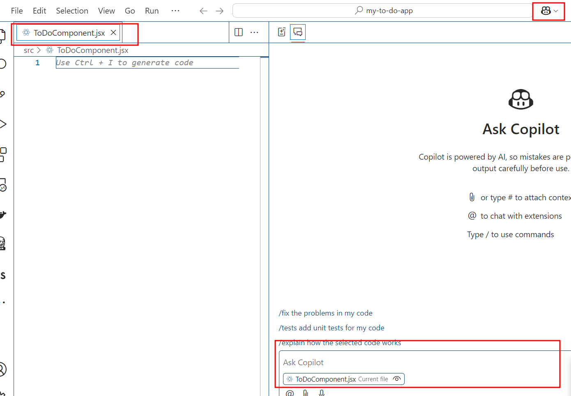

Open the GitHub copilot chat option and write the prompt message to generate the React JS component code.

Then Open the Github copilot terminal and write the prompt message as

“Create React JS Component code to generate the To do logic using”

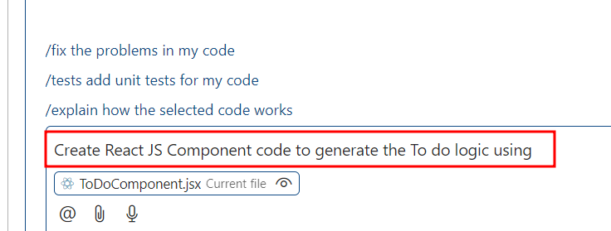

After prompt it generate the code.

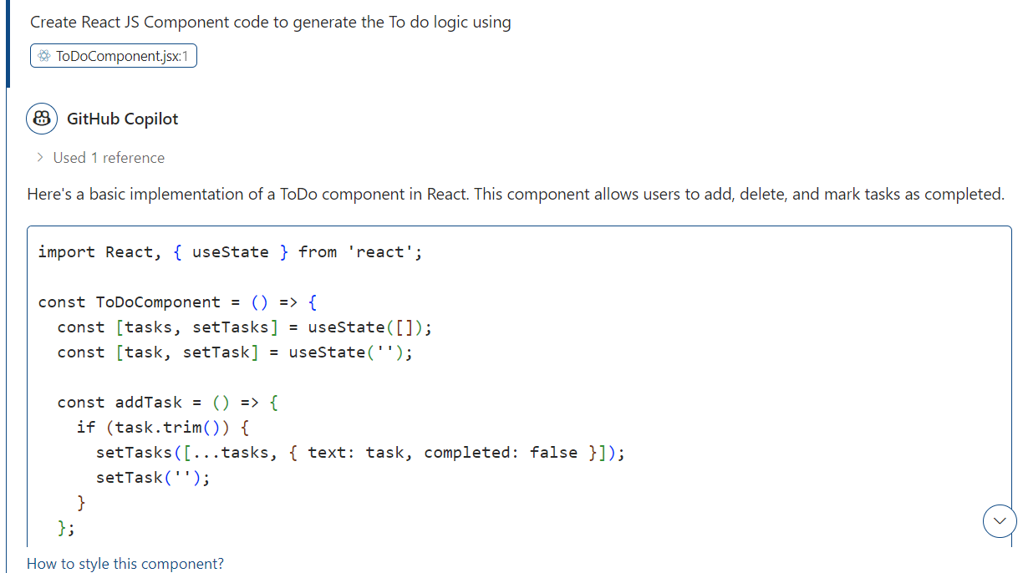

Even GitHub copilot provide the explanation about the generated code.

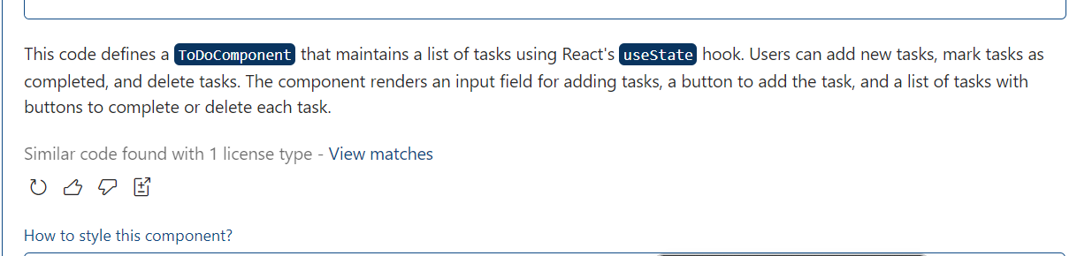

If you like this code you can click on apply this code the component

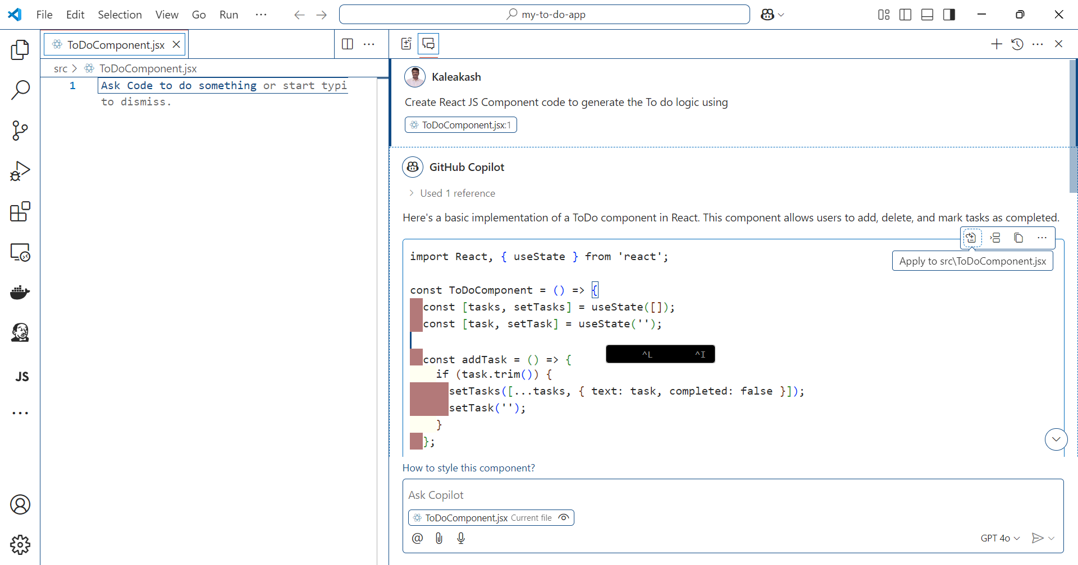

Once you click on Apply to src/ToDoComponent.jsx. This code copy and paste automatically in component tsx file.

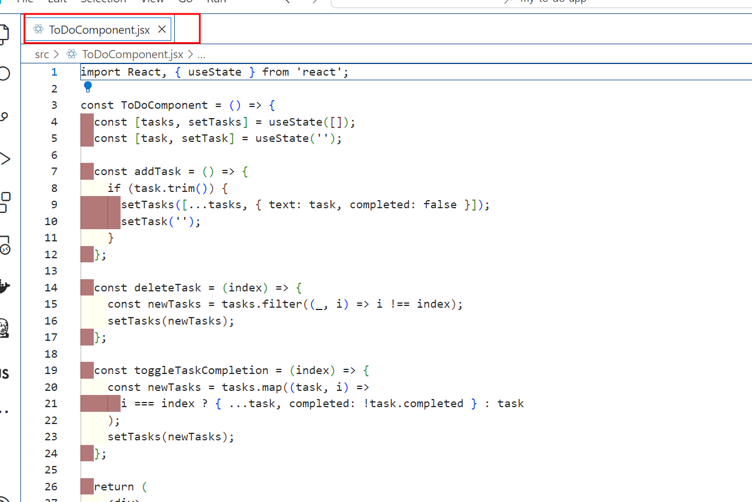

Now Open the App.jsx file and include this component.

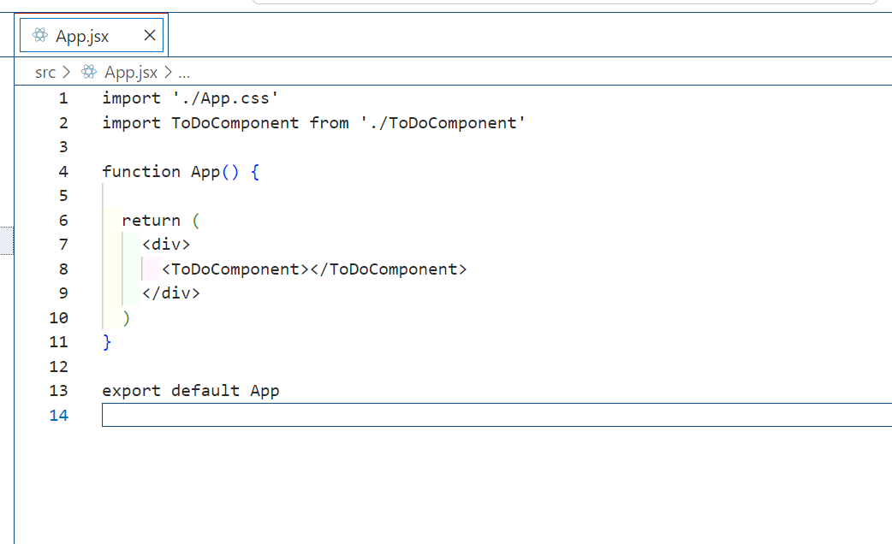

Now check the updated output on browser

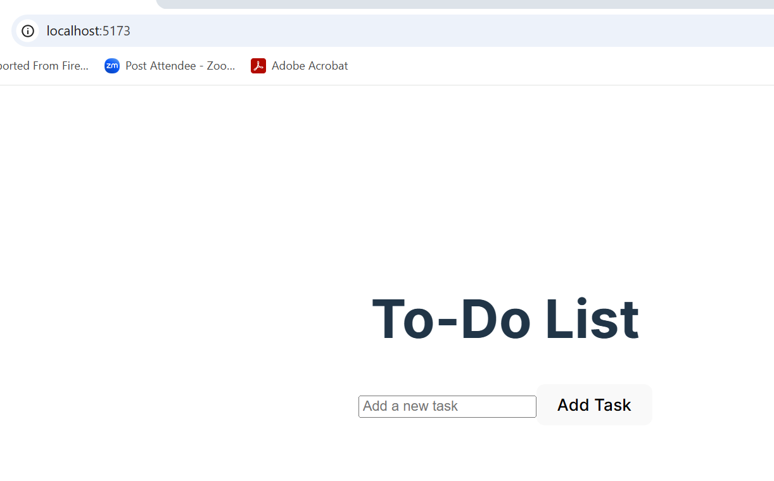

Add few more task you want to do.

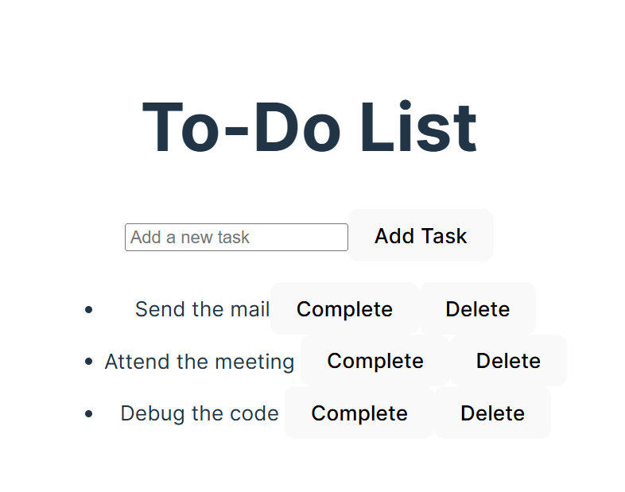

Make few task complete.

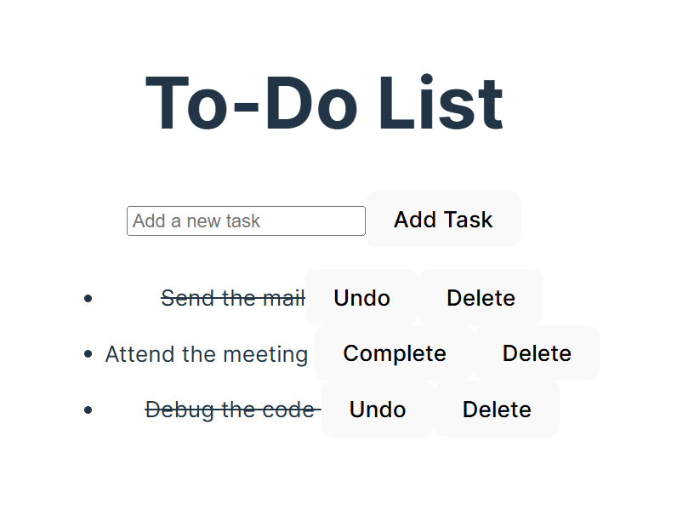

Remove few task.

